Script for interviews
Version 2.0

Introduction:
Scope: We are interessed in your Scrum process and how it is supported by artefacts.
Time: about 1 hour

Facts:
- How many years of scrum experience do you have (exact number +-1year)
- Job title
- How many projects?
- Many projects available → choose one to talk about: current one or longest one or pick the one they prefer to talk about. Choose the most relevant for tools / last one (for actual informations). Ask for project duration.

Scrum Diagram:
First of all I intend to understand the perception of Scrum you have in your team and to find out how your development process is organized.
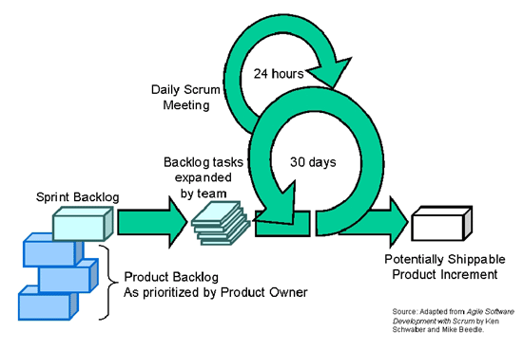

(drawing theoretical version of the Scrum diagram on a whiteboard, by hand, black color)

This is the Scrum process as we know it from theory. There is a product backlog from which the user stories for the current sprint are chosen and will go to the sprint backlog. This is the sprint planning (partecipants: Scrum Master, Product Owner, Team).
There will then be a sprint in which the chosen features will be implemented and in the end of each sprint there will be a potentially shippable product increment. This sprint in theory has a fix duration of 30 days. A daily stand-up meeting called Daily Scrum Meeting (Scrum Master, Team) takes places, usually in the morning. At the end of each sprint, there will be a meeting with Scrum Master and the developers team in order to learn from faults committed with regard to the Scrum process (Scrum retrospective). Also there will be a sprint review (Team, Scrum Master, Product Owner).

What other meetings not yet mentioned in the diagram do you have in your process? Please add them to the diagram.

What are the roles you are using in your process? In which meetings do the different roles participate? What are the people of the different roles doing? Who is making decisions in which phase of the process?
(In theory we have the well-separated roles of Scrum Master, Product Owner and the developers team.)

Knowledge sharing is an important factor of Scrum. How do you share knowledge in your process? Can you indicate in the diagram where the knowledge transfer is in your process? {Backup: Compare other development processes, you have worked with in past, with Scrum. What are the similarities with regard to knowledge transer? What are the differences to Scrum with regard to knowledge transfer? What are the benefits of Scrum with regard to knowledge transfer / communication?}

(New color blue on the whiteboard for artefacts)
What artefacts do you use to support the different stages of the process?
{Backup: How do you use the whiteboard/walltools/post-its? Do you use different tools for different aspects/stages?}
→ for each artefact:
- Which version of the tool do you use?
- What are the points you like about this artefact? What are the points you do not like about this artefact?
- Which role does what in the tool?
- How did you adapt and/or configure the tool?
- Were you involved in the selection process of this artefact? If yes, how did you select this artefact?
- How does the team use the tools differently than the business people? Does the tool handle these differences?
Is there data tracked in other artefacts (for example SVN, Post-its on the wall)?
If there are many artefacts/tools, let them rate each of them from 1 to 5.
{Backup: Indicating one by one the different stages and asking in particular how the stage is handled}

How do you handle versioning/ update of documents?
How do you differentiate between project level and product level?
How is the process visible to the developers/team? Does the tool handle this visibility or is it a need?

If using Scrum for more than 2 years in this team: Compare the process of the first year to the process of the current year. What are the differences?
What are the points you were able to improve? How did you refine the process from the first year to the current year?
{Backup: What are the lessons learnt? Did you abandone some tools that didn't sadisfy the needs? If yes, which needs they did not fulfill?}

Indicate the painpoints of your process on the diagram (red color).
{Explain what the problems are there.}
Indicate the positive points on the process diagram (green color).
{Explain how come they are perceived as positive.}

What are your likes of the process diagram (green color)?
What are your dislikes of the process diagram (red color)?

How would you represent bug reporting in the process diagram?
{Backup: Do bugs enter as new features in the product backlog?}

Final part:
Do you have any more questions for us?
Can we contact you by e-mail for further questions?
Thank you very much for your time and your contribution.

Points to remember:
→ write more on the whiteboard / draw during interview
→ several process diagrams for several projects
→ we want to know: Who is making decisions
→ diagram of the roles → what does the different roles do?
→ when changing topic → „So next let's talk about ...“
→ take camera along

